How to use the Text/Comment Anonymizer tool
The Text/Comment Anonymizer tool uses dictionary-based matching and a Named Entity Recognition model to automatically anonymize responses in various open text responses or data containing strings and characters. Anonymization is Salve-specific, targeting words and that may identify the university and individual person names, replacing them with bracketed tags (i.e. “[person]”). The user has a choice whether to anonymize Institution names (Salve, Salve Regina), Building names (Miley, O’Hare) or Person names (Faculty, Staff, Students).
NOTE: Please ensure that both R and RStudio are installed on your computer, as this tool requires them to function.
Locate the file here: \\go.salve.edu\pirc$\Comment-Text Anonymizer Tool\Comment-Text Anonymizer Tool.R
- Open the file in R-Studio
- Click the green Run App button in the top right corner of the code window to start the app, shown below (May take a few minutes to execute for the first time, since packages and dependencies will download automatically)
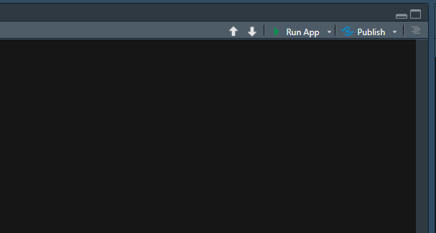

  - The tool should then open as an app in a new window, make full screen for easier experience/navigation
- In the box on the left, click Browse and search for the desired .xlsx file to upload
  - Ensure the excel file contains one singular column of text data (i.e. one column of open comments from a survey)
  - A unique identifier column (i.e. Student ID) is not required for the app to run but recommended
  - After file is selected, a customizable preview should show up to the left of the box
- Click the check boxes to select which categories to anonymize/replace
- Click the blue Anonymize button to run the application
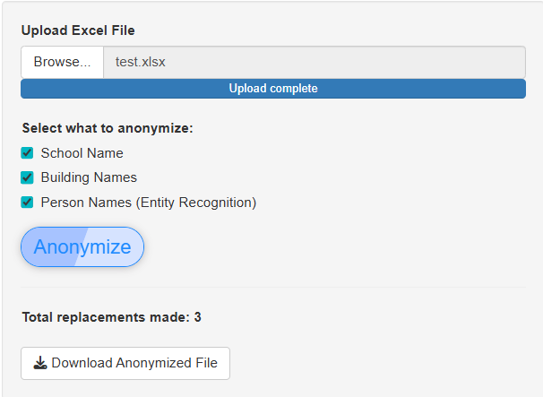
  - If the tool was successful, a pop-up window will appear with a check mark along with the number of replacements made in the file
7
5
3
4

- Click OK - a customizable preview of the anonymized responses should be visible below the original preview, with replacement tags colored by category
  - Due to the tool using dictionary-based matching and a NER model, there may be words that have been missed – it is recommended to scan through the anonymized responses and note any inaccuracies
  - See below for instructions on how to add words to the dictionaries to be replaced
- Click Download Anonymized File to save the anonymized file for upload to LLMs for thematic analysis or other use cases

